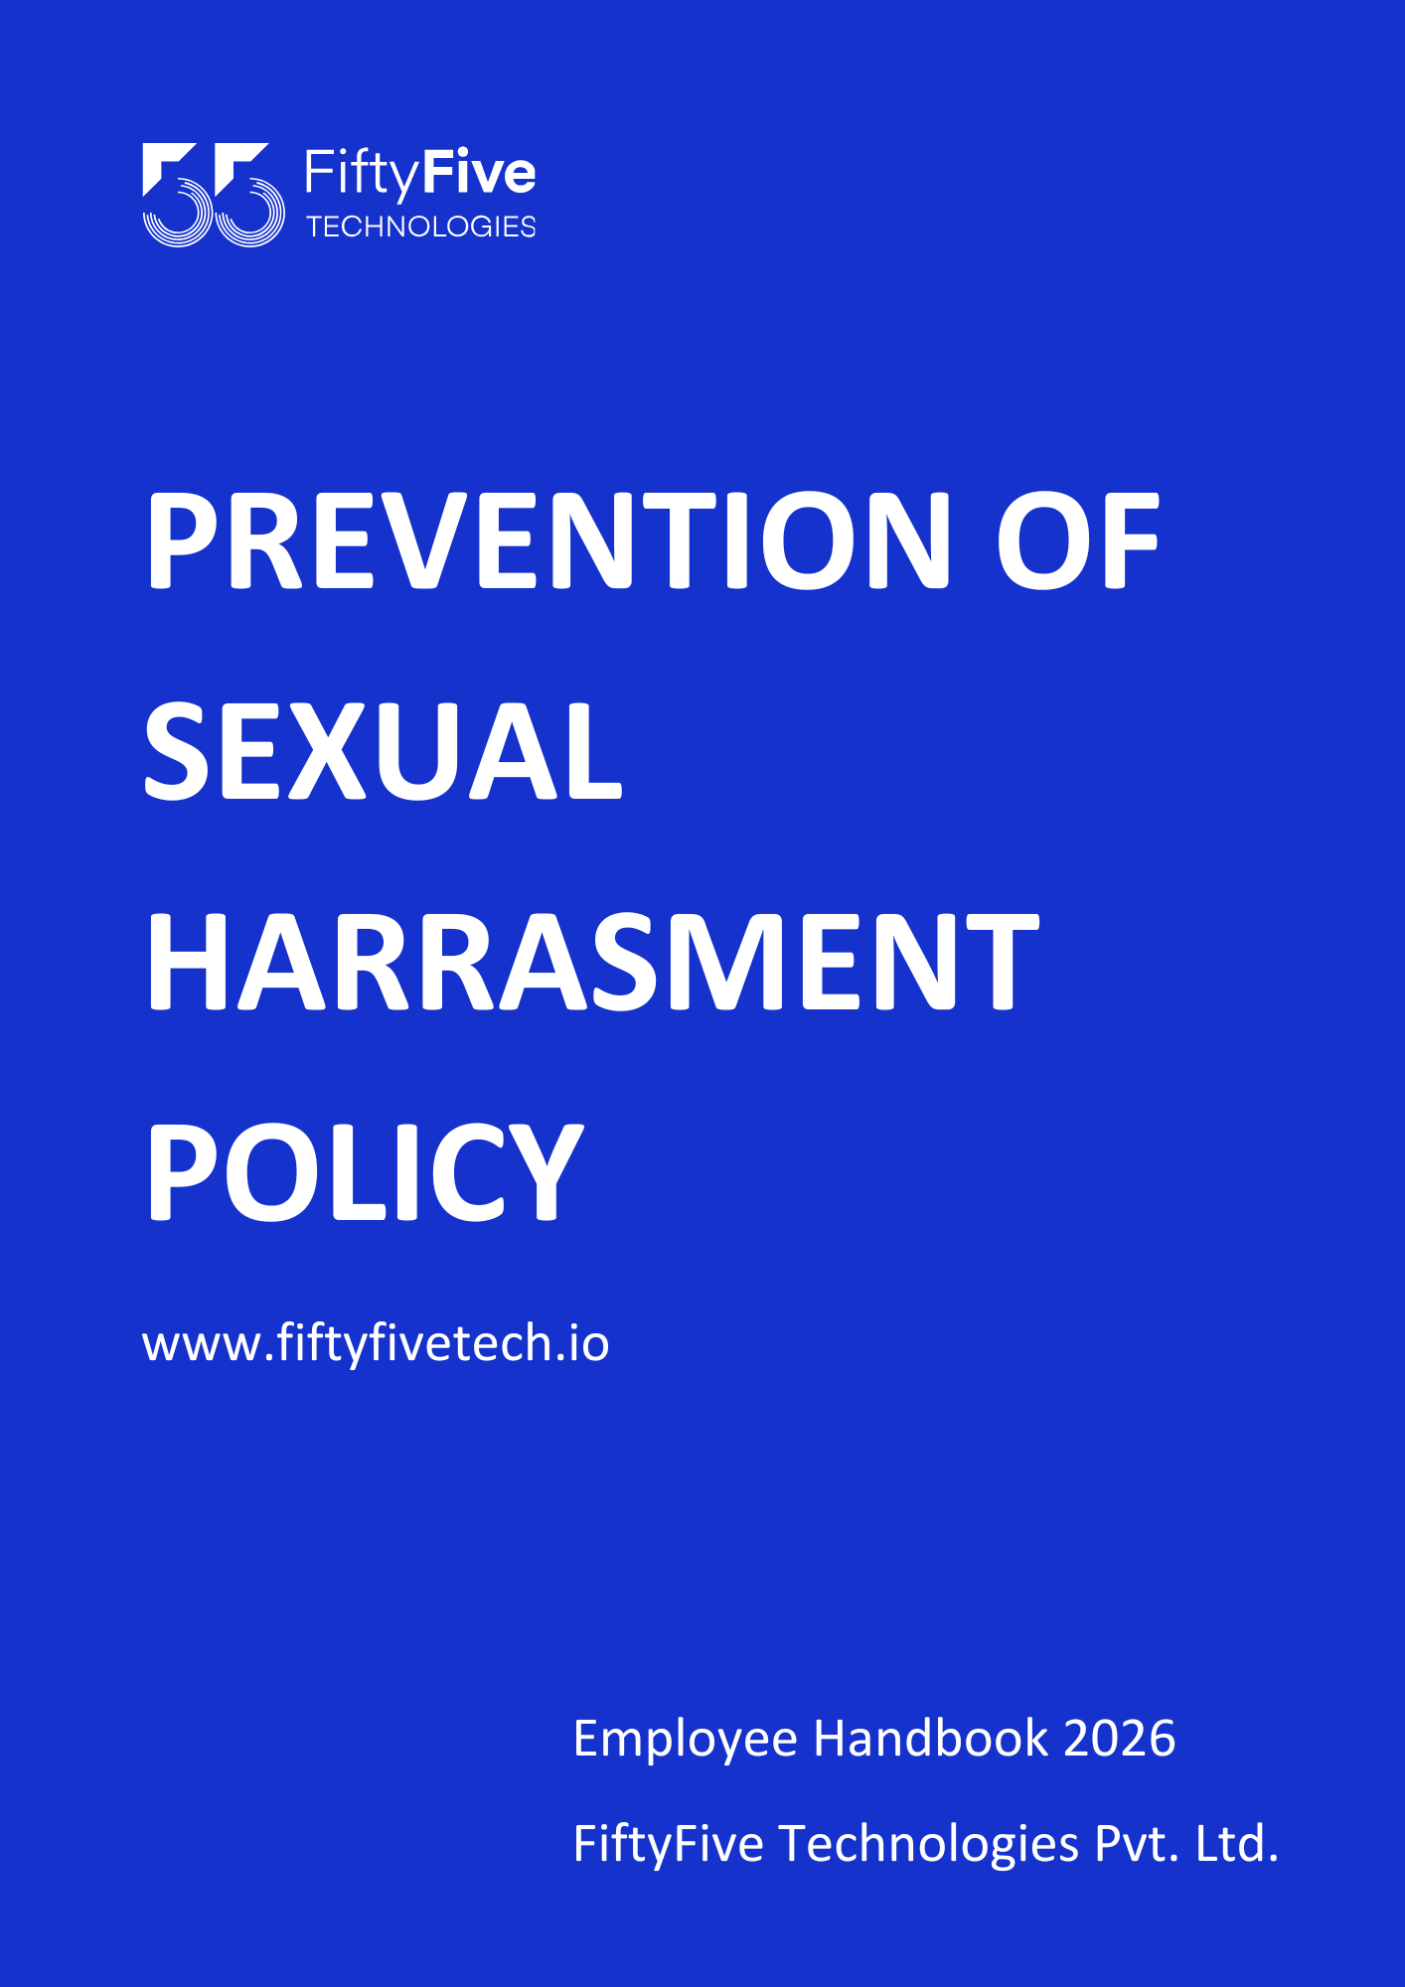

Prevention of Sexual Harassment in The Workplace Policy

Document Release Notice

This FiftyFive Technologies Policy on sexual harassment in the workplace policy is released for use in FiftyFive Technologies Pvt Limited with effect from 01 January 2026.

This document is subject to FiftyFive Technologies Pvt Limited Procedure and subject to change any time as per the company policy.

Approved By: Jyothi Sharma (CEO-FiftyFive Technologies Pvt. Limited) Approved By: Sanchi Saxena (Head HR-FiftyFive Technologies Pvt Limited)

PREVENTION OF SEXUAL HARASSMENT

Introduction
This policy “Prevention of Sexual Harassment Policy” has been framed in reference to the requirement of “Sexual Harassment of Workmen at Workplace (Prevention, Prohibition and Redressal) Act, 2013” and rules framed thereunder (hereinafter referred to be as “the Act”). Accordingly, this Policy covers all the important aspects of the Act and rules framed thereunder. However, for any clarification, the respective provisions of the Act and rules shall prevail over this Policy.

Objective
Our Company is committed to providing a work environment that ensures every employee is treated with dignity and respect and afforded equitable treatment. The Company is also committed to promoting a work environment that is conducive to the professional growth of every employee and encourages equality of opportunity. The Company will not tolerate any form of sexual harassment and is committed to taking all necessary steps to ensure that its employees are not subjected to any form of harassment.

Scope
This Policy applies to all categories of employees of the Company, including permanent management and workmen, temporaries, trainees, and employees on contract at its workplace or at client sites. The Company will not tolerate sexual Harassment if engaged in by clients suppliers, or any other business associates.

The workplace includes:

All offices or other premises where the Company’s business is conducted in the ordinary course.

All company-related activities performed at any other site away from the Company’s premises.

Any place visited by the employee arising out of or during the course of employment including transportation provided by the employer for undertaking such journey.

Definition of Sexual Harassment –
According to Sexual Harassment of Women at Workplace (Prevention, Prohibition and Redressal) Act, 2013, Sexual Harassment includes any one or more of the following unwelcome acts or behavior(whether directly or by implication) namely:
  - physical contact and advances; or
  - a demand or request for sexual favor; or
  - making sexually colored remarks; or
  - showing pornography; or
  - any other unwelcome physical, verbal or non-verbal conduct of sexual nature;

The Sexual harassment is “an unacceptable conduct of a sexual nature, or other conduct based on sex abuse affecting the dignity of men or women at work”. Sexual harassment will generally be unwanted, unreasonable or offensive or it may be a combination of all three. It may cause the employee who is being harassed to feel threatened or humiliated. It may interfere with the employee’s job performance, undermine job security or create a threatening or intimidating working environment. Although the word “harassment” has connotations of repeated conduct, an employee can be harassed by a single act. Sexual harassment can consist of several different types of behavior, some of which are more obvious than others. This list is not exhaustive but,
for example:-

  - Sexual harassment can take the form of gestures or leering,
  - Sending letters,
  - Gifts or offensive publications or the use of pin-ups
  - Unwanted jokes, gestures, offensive words on clothing, and unwelcome comments and repartee
  - Touching and any other bodily contact such as scratching or patting a coworker's back, grabbing an employee around the waist, or interfering with an employee's ability to move.
  - Repeated requests for dates that are turned down or unwanted flirting
  - Transmitting or posting emails or pictures of a sexual or other harassment-related nature.
  - Displaying sexually suggestive objects, pictures, or posters.
  - Playing sexually suggestive music.

Alternatively, sexual harassment may consist of spoken comments, including unwanted propositions, jokes of a sexual nature, questions or comments of a sexual nature or the suggestion that an employee’s career can be 2 advanced by bestowing sexual favors (or alternatively that an employee’s career will be damaged if they do not accede to sexual requests). A third sort of sexual harassment involves physical contact including “accidental” contact, or deliberate patting, fondling or groping.

Internal Complaints Committee:
The Company has constituted an Internal Complaints Committee (“ICC”) in accordance with the Section 4of the Act. The Committee is constituted at all administrative units or offices for redressal of sexual harassment complaint (made by the victim) and for ensuring time bound treatment of such complaints.

Internal Complaints Committee
Presiding Officer -
Senior Women & Men Employee
Head of Human Resources of the Company

Following are the members of the committee:

Role
Presiding Officer
Presiding Officer
Head HR

At the time of inquiry, Minimum 3 members including Presiding Officer shall be present. The group shall include the Presiding Officer and at least three members, one-half of whom shall be women.

Redressal Process
- Any employee who feels and is being sexually harassed directly or indirectly may submit a complaint of the alleged incident to any member of the Committee in writing with his/her signature within 3 Months of occurrence of incident. The Internal Complaint Committee may extend the time limit for a reasonable cause. Complaint shall be submitted in six copies along with supporting documents and the names and address of witnesses.
- If a complaint cannot be made in writing, the Committee shall provide reasonable assistance to the employee for making the complaint in writing.
- If the aggrieved employee is unable to make a complaint, then any of her legal heir may make a complaint on his/ her behalf.
- The committee shall send one copy of complaint to the respondent within a period of 7 days and respondent shall file his reply within a period of 10 days.
- The committee at the request of the aggrieved employee shall take the steps to settle the case through conciliation without involving any monetary settlement as a basis of conciliation and where the settlement has been arrived, no inquiry shall be conducted.
- In case, respondent is an employee, the committee shall, proceed to make an inquiry in accordance with the provisions of service rules applicable to the respondent or other prescribed rules and in case of domestic worker, the local committee shall forward the complaint to the police within 7 (Seven) days for registering the case under Indian Penal Code, 1860, except for those cases which has been arrived for settlement as mentioned in point (5) above.
- The inquiry shall be completed within a period of 90 days.
- The committee shall provide a report of findings to the employer within 10 days of completion of inquiry and also to the concerned parties and opportunity of being heard shall also be given to them.
- If an allegation against the respondent has been proved, the committee shall recommend to the employer.

- In case, the complaint is found to be false, the Complainant shall, if deemed fit, be liable for appropriate disciplinary action by the Management but a mere inability to substantiate a complaint or provide adequate proof need not attract action against the Complainant.
    - to take adequate action for sexual harassment as a misconduct in accordance with the provisions of the service rules applicable to the respondent;
    - to deduct, notwithstanding anything in the service rules applicable to the respondent, from the salary or wages of the respondent such sum as it may consider appropriate.
- If the Complainant was aggrieved from the recommendation made by Committee to employer then he/she may prefer appeal to the appellate authority notified under clause (a) of Section 2 of the Industrial Employment (Standing Orders) Act, 1946.
- The Committee will maintain a register to endorse the complaint received by it and keep the contents confidential, if it is so desired, except to use the same for discreet investigation.
- The Committee will hold a meeting with the Complainant within five days of the receipt of the complaint, but no later than a week in any case.
- At the first meeting, the Committee members shall hear the Complainant and record her/his allegations. The Complainant can also submit any corroborative material with a documentary proof, oral or written material, etc., to substantiate his/ her complaint. If the Complainant does not wish to depose personally due to embarrassment of narration of the event, a lady officer for lady employees involved and a male officer for male employees involved shall meet and record the statement.
- Thereafter, the person against whom a complaint is made may be called for a deposition before the Committee and an opportunity will be given to him/ her to give an explanation, where after, an “Enquiry” shall be conducted and concluded.
- In the event, the complaint does not fall under the purview of Sexual Harassment or the complaint does not mean an offence of Sexual Harassment, the same would be dropped after recording the reasons thereof in writing.

Enquiry Process
  - The Committee shall immediately proceed with the Enquiry and communicate the same to the Complainant and the person against whom the complaint is made
  - The Committee shall prepare and hand over the Statement of Allegation to the person against whom the complaint is made and give him/ her an opportunity to submit a written explanation if he/ she so desires within 7 days of receipt of the same.
  - The Complainant shall be provided with a copy of the written explanation submitted by the person against whom complaint is made.
  - If the Complainant or the person against whom complaint is made desires any witness/es to be called, they shall communicate in writing to the Committee the names of witness/es whom they propose to call.
  - If the Complainant desires to tender any documents by way of evidence before the Committee, she/ he shall supply original copies of such documents. Similarly, if the person against whom a complaint is made desires to tender any documents in evidence before the Committee she/ he shall supply original copies of such documents.
  - The Committee shall call upon all witnesses mentioned by both the parties.
  - The Committee shall provide every reasonable opportunity to the Complainant and to the person against whom complaint is made, for putting forward and defending their respective case.
  - The Committee shall complete the “Enquiry” within a reasonable period but not beyond three months and communicate its findings and its recommendations for action to the HR . The report of the committee shall be treated as an enquiry report on the basis of which an erring employee can be awarded appropriate 4 punishment straightaway.
  - The HR will direct appropriate action in accordance with the recommendation proposed by the Committee.
  - The Committee shall be governed by such rules as may be framed by the Supreme Court orders or any other legislation enacted later on.

Filing a Complaint Process Flow Chart

Report Incident within 3 Months
Complain to ICC
Notify Respondent (7 Days)
Get Responses (10 days)
Enquiry (90 Days)
Settlement or Punishment
Action (60 Days)
Does Respondent Agree

No

Yes

Other Points to be considered
- The Committee may recommend the VP-HR action which may include transfer or any of the other appropriate disciplinary action.
- The management shall provide all necessary assistance for the purpose of ensuring full, effective and speedy implementation of this Policy.
- Where sexual harassment occurs as a result of an act or omission by any third party or outsider, TPC shall take all steps necessary and reasonable to assist the affected person in terms of support and preventive action.
- The Committee shall analyze and put up a report on all complaints of this nature at the end of the year for submission to VP- HR.
- In case, the Committee finds the degree of offense coverable under the Indian Penal Code, then these facts shall be mentioned in its report and appropriate action shall be initiated by the Management, for making a Police Complaint.

Actions against Harassment can Include:-
  - Written disciplinary warnings
  - Demotion
  - Suspension
  - Termination

Confidentiality
The Company understands that it is difficult for the victim to come forward with a complaint of sexual harassment and recognizes the victim’s interest in keeping the matter confidential. To protect the interests of the victim, the accused person and others who may report incidents of sexual harassment, confidentiality will be maintained throughout the investigatory process to the extent practicable and appropriate under the circumstances. The contents of complaint, the identity and addresses of the aggrieved woman, respondent and witnesses, any information relating to conciliation and inquiry proceedings, recommendations of the Internal Committee and the action taken by the employer shall not be published, communicated or made known to the public, press and media in any manner.

Access to Reports And Documents

All records of complaints, including contents of meetings, results of investigations and other relevant material will be kept confidential by the Company except where disclosure is required under disciplinary or other remedial processes.

Right to Amend Policies
This Employee Handbook is intended to provide general guidance on Company policies and practices. FiftyFive Technologies reserves the right to amend, modify, suspend, or withdraw any policy, procedure, or benefit described in this handbook at any time, with or without notice, based on business, operational, or legal requirements.



